

CSA15 – CLOUD COMPUTING AND BIG DATA ANALYTICS

ASSIGNMENT 1 – CO1

Design, Analyse and Validate a Cloud-Based Solution for Migrating a Legacy University Management System
CO1: Apply cloud computing technologies including hardware–software evolution, virtualization, web services, and service models to develop cloud-based solutions.

Field | Details | Field | Details
Student Name | M.Greeshma | Register Number | 192524195
Department / Section | AI & DS | Academic Year / Semester
Faculty Name | Dr.R.Latha | Nature of Assignment | Individual
Duration | 1 Week | Total Marks | 50
Submission Date |  | Evaluation Date

MARK SHEET (Rubric-based evaluation)
Task | Title | Max | Awarded | Evidence / evaluation focus
1 | Introduce Cloud Computing | 3 |  | Definition; characteristics;  deployment models; scenario mapping
2 | Trace Evolution and Hardware Evolution | 3 |  | Timeline; hardware evolution; relevance to university
3 | Analyse Internet Software Evolution | 3 |  | Web/software evolution; SOA; APIs; scenario relevance
4 | Apply Server Virtualization | 5 |  | Hypervisor types; VM/container comparison; consolidation; limitations
5 | Apply Web Services | 4 |  | SOA and SOAP/REST; three university APIs; request/response examples
6 | Analyse IaaS, PaaS and SaaS | 5 |  | Responsibility layers; five-application mapping; comparison; providers
7 | Examine XaaS | 3 |  | Four or more variants; two justified choices; provider risks
8 | Design Cloud Solution | 5 |  | Labelled diagram;

 | Architecture |  |  | deployment/service models; scaling;  security; DR
9 | Hands-on Implementation and Documentation | 4 |  | Running VM/container; PaaS/SaaS; tests; actual screenshots
10 | Evaluate and Recommend Final Solution | 7 |  | Three-way comparison; 3-year costs; risks; phased roadmap
11 | Day-4 Design Challenge | 8 |  | Impact; evaluation; adaptation; evidence-based defence
 | TOTAL | 50 |  | Percentage :

EVIDENCE VERIFICATION CHECKLIST

Tasks | Evidence expected | Status (✓  / P / ✗ ) | Evaluator note
1–3 | Conceptual explanations, comparisons and relevant illustrations | ✓ | Explanations and relevant scenario mapping documented
4 | Virtualization calculations with  stated assumptions and peak-load caution | ✓ | Calculations present; practical capacity validation  recommended
5–7 | API examples, service responsibility table and justified XaaS choices | ✓ | Required conceptual evidence documented
8 | Labelled architecture diagram,  caption below figure and component justification | ✓ | Architecture documented;  sizing assumptions need testing
9 | Actual code, environment details, execution logs, API outputs and screenshots | P | Procedures provided; actual execution evidence not  established
10 | Cost assumptions, 3-year totals, risk controls and migration roadmap | ✓ | Estimates and rationale documented
11 | Day-4 changes, 10× load strategy, 99.9% target and 40-college isolation | ✓ | Design analysis documented; practical validation pending

IMPLEMENTATION EVIDENCE CHAIN

Evidence item | Status | Observation
Source code | ✓ | Flask REST API and Dockerfile provided in the proposed implementation
Virtualization | P | Docker container configuration documented; running-container evidence required
PaaS or SaaS | P | Managed web-service deployment procedure described; live deployment not verified
Functional test | P | Expected HTTP 200 response and JSON output documented; actual output required

Failure case | P | HTTP 404 test case documented; actual execution record required
Screenshots | P | Screenshot requirements identified; authentic screenshots need verification
Reproducibility | ✓ | Build commands, run commands, endpoints and expected results specified

OVERALL REMARKS

Student Signature | Faculty Signature | Program Director

MANDATORY SUBMISSION EVIDENCE CHECK
✓ = Present in documented answer; P = Partly present; ✗ = Missing / not satisfied

Task | Evidence expected | Status | Evaluator note
1 | Cloud definition, characteristics, deployment models and scenario mapping | ✓ | All conceptual requirements covered
2 | Evolution timeline, hardware  development and university relevance | ✓ | Well explained with relevant examples
3 | Internet software evolution, SOA and APIs | ✓ | Clear explanation and scenario relevance
4 | Hypervisors, VM/container  comparison and consolidation calculations | ✓ | Calculations included; peak-load limitations discussed
5 | SOAP/REST comparison and three university APIs | ✓ | API methods and request/response examples documented
6 | IaaS/PaaS/SaaS responsibility layers and application mapping | ✓ | All five applications categorized with justification
7 | XaaS variants and two justified selections | ✓ | Six variants explained; DBaaS and DRaaS recommended
8 | Labelled architecture, scaling, security and disaster recovery | ✓ | Design and component justifications documented
9 | Working container, PaaS/SaaS deployment, actual tests and screenshots | P | Code and procedures provided; actual  execution evidence requires verification
10 | Three-year cost comparison, risks and migration roadmap | ✓ | Cost assumptions, calculations and recommendations included
11 | Impact analysis, 10× load, 99.9% availability and tenant isolation | ✓ | Changed requirements evaluated; load-test evidence recommended

IMPLEMENTATION EVIDENCE CHAIN

Evidence item | Status | Observation
Source code | ✓ | Python Flask REST API and Dockerfile documented
Virtualization | P | Docker build and run procedures provided; execution screenshot required
PaaS or SaaS | P | Cloud deployment steps described; actual deployment confirmation required
Functional test | P | HTTP 200 and expected JSON response documented; actual

 |  | test output required
Failure case | P | HTTP 404 test case included; execution evidence required
Screenshots | P | Required screenshots identified but authenticity and completeness not verified
Reproducibility | ✓ | Installation, configuration, commands and testing steps documented
Interpretation | ✓ | Technical outcomes and implementation limitations explained
Code and report consistency | ✓ | Proposed API, Docker configuration and testing procedure are aligned

SUBMISSION CHECKLIST (Not Separately Marked)

Requirement | Status
All 11 tasks answered | ☒ Yes ☐ Partly ☐ No
Cloud concepts and comparisons explained | ☒ Yes ☐ Partly ☐ No
Virtualization calculations included | ☒ Yes ☐ Partly ☐ No
API examples and service models explained | ☒ Yes ☐ Partly ☐ No
Cloud architecture diagram included | ☒ Yes ☐ Partly ☐ No
Implementation and testing evidence provided | - Yes ☒ Partly ☐ No
Three-year cost analysis and roadmap included | ☒ Yes ☐ Partly ☐ No
Day-4 design challenge completed | ☒ Yes ☐ Partly ☐ No
Figures and screenshots included | - Yes ☒ Partly ☐ No
Table and figure numbering correct | - Yes ☒ Partly ☐ No
Viva recommended | ☒ Yes ☐ No

CSA15 – Cloud Computing and Big Data Analytics

ASSIGNMENT 1
CO1: Apply cloud computing technologies including hardware–software evolution, virtualization, web services, and service models to develop cloud-based solutions.

Assignment Title: Design, Analyse and Validate a Cloud-Based Solution for Migrating a Legacy University Management System (Total Marks – 50)

Duration: 1 week

Scenario – Smart Campus Cloud Migration
A multi-campus university currently runs its Student Information System, Learning Management System, Library System, Exam Portal and Email on ageing physical servers in a single on-premise data centre. Each application has its own dedicated server, which stays idle for most of the year but fails to cope during admissions, result publication and online-exam weeks.
The university's current environment is:
- 12 physical servers, average CPU utilisation of about 15%, with peaks above 95% during admissions and exams
- Approximately 25,000 students and 2,000 staff across 4 campuses
- Applications built as large monolithic programs, with no public interfaces for mobile apps or partner colleges
- High capital expenditure, slow procurement (6–8 weeks per server) and no disaster recovery site
As a cloud consultant, you must study how computing evolved to the cloud model, and then design a cloud-based solution that uses virtualization, web services and an appropriate mix of service models (IaaS, PaaS, SaaS and XaaS) for the university. All recommendations must be justified in terms of cost, scalability, availability and manageability.

Design Challenge:
On Day 4, the university announces that it will launch a mobile app and open student-record and fee-payment services to 40 affiliated colleges. Expected load is 10 times the current peak, with a requirement of 99.9% availability and a limited operating budget. Re-evaluate your original design and decide whether it should be retained, modified or redesigned.

TASK 1 – Introduce Cloud Computing and Map It to the Scenario (3 Marks)

Design and Propose cloud computing model for the context of the university's problems.
- Definition of cloud computing and the five essential characteristics (on-demand self-service, broad network access, resource pooling, rapid elasticity, measured service)
- Deployment models (public, private, hybrid, community) and which one suits the university
- Three problems of the current on-premise setup and how each cloud characteristic addresses them
- Benefits and limitations of cloud adoption for the university

Evidence Expected
A clear explanation of cloud characteristics and deployment models, mapped to the university's actual problems.

TASK 2 – Trace the Evolution and Hardware Evolution (3 Marks)
Trace how computing infrastructure evolved to make cloud computing possible.
- A timeline from mainframes, minicomputers and PCs, to client–server, clusters, grid computing, utility computing and cloud
- Hardware evolution: multi-core processors, commodity servers, high-capacity storage, high-speed networking and data centres
- How each stage solved a limitation of the previous one
- Which stage the university's current system corresponds to, with reasons

Evidence Expected
A labelled timeline or diagram, with a justified explanation of how hardware advances enabled the cloud.

TASK 3 – Analyse Internet Software Evolution (3 Marks)
Explain how internet software evolved and why it supports cloud services.
- Evolution from static web pages to dynamic web, Web 2.0, SOA, mashups and cloud-hosted applications
- Role of browsers, HTTP, AJAX and APIs in delivering software over the internet
- Comparison between desktop software, client–server software and web-delivered software
- How this evolution affects the design of the university's applications

Evidence Expected
A comparative explanation of software evolution stages, linked to the university's application design.

TASK 4 – Apply Server Virtualization (5 Marks)
Apply server virtualization to consolidate the university's 12 physical servers.
- Explain how a hypervisor works, and distinguish Type-1 and Type-2 hypervisors, with examples
- Compare full virtualization, para-virtualization, OS-level virtualization (containers) and hardware-assisted virtualization
- Propose which applications should run as virtual machines and which as containers, with reasons
- Calculate the consolidation: with an average utilisation of 15% per server and a target host utilisation of 70%, estimate how many physical hosts are needed (show your assumptions and working)
- Discuss live migration, snapshots and resource over-commitment as benefits, and the risks of virtualization (noisy neighbour, hypervisor failure, security isolation)

Show your calculation. A final number without working will not receive full credit.

Evidence Expected
A justified virtualization plan with a worked consolidation calculation and discussion of benefits and risks.

TASK 5 – Apply Web Services (4 Marks)
Analyse web services to expose the university's functions to other systems.
- Overview of web services and their role in cloud and SOA
- Compare SOAP, WSDL, UDDI and RESTful services (HTTP methods, JSON/XML)
- Identify at least three university functions to expose as web services (for example, result lookup, fee payment, library search) and define the endpoint, method and sample request/response for each
- Justify whether SOAP or REST is more suitable for each function

Evidence Expected

A defined set of web services with sample request/response formats and a justified choice of SOAP or REST

TASK 6 – Analyse the Service Models: IaaS, PaaS and SaaS (5 Marks)
Analyse which service model fits each university application.
- Define IaaS, PaaS and SaaS, and show who manages which layer (hardware to application) in each model
- Categorise the five university applications (SIS, LMS, Library, Exam Portal, Email) into IaaS, PaaS or SaaS, with reasons
- Compare the models on control, cost, scalability, maintenance effort and vendor lock-in
- Give one real provider example for each model
Present your categorisation in a table, but explain the reasoning behind each
decision. A table alone is not sufficient.

Evidence Expected
A reasoned mapping of applications to service models, supported by a layer-wise responsibility comparison.

TASK 7 – Examine XaaS (3 Marks)
Examine the broader XaaS (Anything-as-a-Service) concept for the university.
- Explain XaaS and describe at least four variants (for example DaaS, BaaS/MBaaS, FaaS, DBaaS, Security-as-a-Service, Disaster-Recovery-as-a-Service)
- Select two XaaS offerings that would benefit the university, and justify them
- Discuss the risks of over-reliance on multiple 'as-a-Service' providers

Evidence Expected
An analysis of XaaS variants, with justified selection of two offerings for the university.

TASK 8 – Design the Cloud Solution Architecture (5 Marks)
Bloom's Level: Level 6 – Create | Action verbs: Design, Construct, Propose
Create a complete cloud architecture for the university by combining virtualization, web services and service models.
- An architecture diagram showing users, load balancer, web/application tier, database tier, storage, API layer and DR region

- The deployment model and the service model chosen for each component
- How elasticity (auto-scaling) will handle admissions and exam peaks
- Basic security and availability measures (access control, encryption, backup, multi-zone deployment)

Evidence Expected
A labelled architecture diagram with written justification for each component and design decision.

TASK 9 – Hands-on Implementation and Documentation (4 Marks) Implement a small proof-of-concept of your design using a free-tier cloud account or a local virtualization tool.
- Create a virtual machine or container (using AWS/Azure/GCP free tier, VirtualBox, or Docker) and host a simple web page or REST API for one university function
- Deploy a SaaS or PaaS component (for example a cloud-hosted database, a serverless function or a static site)
- Test the web service with a client (browser, Postman or curl) and record the output
- Provide screenshots, configuration steps and any issues faced

Evidence Expected
Annotated screenshots and clear, reproducible steps showing that the proof-of-concept works.

TASK 10 – Evaluate and Recommend the Final Solution (7 Marks)
Evaluate your design and recommend the final cloud solution for the university.
- Compare on-premise, IaaS-based and PaaS/SaaS-based options on cost (CapEx vs OpEx), scalability, availability, security and effort
- Estimate a simple 3-year cost comparison using stated assumptions
- Identify the main risks (vendor lock-in, data privacy, downtime, skills gap) and give mitigation steps
- Provide your final recommendation and a short migration roadmap (which application moves first, and why)

Your recommendation must be supported by the analysis in the previous tasks. Choosing a popular cloud provider without justification is not sufficient.

Evidence Expected
A technically justified recommendation, supported by a cost comparison, risk analysis and migration roadmap.

DAY-4 DESIGN CHALLENGE

TASK 11 – Re-evaluate and Adapt the Design (8 Marks)

Changed Requirement
The university will now launch a mobile app and open student-record and fee-payment services to 40 affiliated colleges. Expected load is 10 times the current peak, availability must be 99.9%, and the operating budget is limited.
Re-evaluate your original design in response to these changed conditions. You may:
RETAIN → MODIFY → or REDESIGN
your original solution.

Impact Analysis – 2 Marks
Discuss:
- What has changed from the original problem
- Which original assumptions (load, users, availability, cost) are affected
- Why the web services and APIs now become critical
- How multi-tenant access by 40 colleges affects security and isolation
Evidence Expected: A clear analysis of how the changed requirements affect the original cloud design.

Evaluation of the Original Design – 2 Marks
Discuss:
- Whether the chosen service models and virtualization plan can handle a 10x load
- Whether auto-scaling and the single-region deployment are sufficient for 99.9% availability (about 8.76 hours of downtime allowed per year)
- Whether cost remains acceptable under the new load
- Whether another service model or XaaS offering would give better overall results
Evidence Expected: A technically supported evaluation of the original design under the new conditions.

Adaptation or Redesign – 2 Marks
Discuss:
- Decide whether to retain, modify or redesign the solution
- Describe the revised architecture (for example API gateway, container orchestration, serverless components, multi-zone deployment or a hybrid model)
- Explain what changed in the service model mix and in the virtualization approach
- If you retain the original design, give sufficient technical justification for why no change is required
Evidence Expected: An appropriate design response to the changed requirement, with clear technical reasoning.

Evidence-Based Defence – 2 Marks
Discuss:
- Capacity and availability calculations
- Cost comparison between the original and the revised design
- Security and multi-tenancy considerations
- Trade-offs such as vendor lock-in, complexity and migration effort
Evidence Expected: A well-supported final decision that follows logically from the analysis.

MARK DISTRIBUTION

Task | Title | Bloom's Level | Marks
Task 1 | Cloud Computing – Introduction & Characteristics | L2 – Understand | 3
Task 2 | Evolution & Hardware Evolution | L2 – Understand | 3
Task 3 | Internet Software Evolution | L2 – Understand | 3
Task 4 | Server Virtualization | L3 – Apply | 5
Task 5 | Web Services | L3 – Apply | 4
Task 6 | Service Models: IaaS, PaaS, SaaS | L4 – Analyze | 5
Task 7 | XaaS | L4 – Analyze | 3
Task 8 | Design the Cloud Solution Architecture | L6 – Create | 5
Task 9 | Hands-on Implementation & Documentation | L3 – Apply | 4
Task 10 | Evaluate & Recommend the Final Solution | L5 – Evaluate | 7
 | Subtotal

Task 11 | Day-4 Design Challenge | L4 / L5 / L6 | 8
 | TOTAL |  | 50

TASK 1 – Introduce Cloud Computing and Map It to the Scenario

Definition of Cloud Computing
Cloud computing is the delivery of computing services such as servers, storage, databases, networking and software over the Internet. It allows universities to access IT resources whenever required without maintaining expensive physical infrastructure.
Proposed solution: The university can adopt a Hybrid Cloud Computing Model, combining private cloud infrastructure for sensitive student and administrative data with public cloud services for general applications, online classes and scalable storage.

Five Essential Characteristics of Cloud Computing

Characteristic | Explanation | Application in University
On-demand self-service | Users can access resources whenever required without human interaction with the service provider. | Students and faculty can access learning platforms and storage anytime.
Broad network access | Services are available through the Internet using different devices. | Students can access study materials through laptops, tablets and mobiles.
Resource pooling | Computing resources are shared among multiple users. | University departments can share storage and computing resources.
Rapid elasticity | Resources can be increased or decreased based on demand. | Additional resources can be provided during admissions and examinations.
Measured service | Resource usage is monitored and billed based on consumption. | University pays only for the cloud resources it uses.

Cloud Deployment Models

There are four major deployment models:
- Public Cloud: Services are provided over the Internet by third-party providers and shared among multiple customers.
- Private Cloud: Cloud infrastructure is dedicated to a single organization, providing greater control and security.
- Hybrid Cloud: Combines public and private cloud environments to provide flexibility and security.
- Community Cloud: Infrastructure is shared by organizations with common requirements, such as universities or research institutions.

Reason: A hybrid cloud is suitable for the university because sensitive information such as student records, examination results and financial details can be maintained in a private cloud, while public cloud services can support online learning, websites and general applications.

Three Problems in the Existing On-Premise Setup

Existing Problem | Cloud Characteristic | Proposed Solution
High maintenance costs and manual hardware management. | On-demand self-service | Cloud resources can be accessed without purchasing and maintaining additional physical servers.
Limited storage and server capacity during admissions and examinations | Rapid elasticity | Computing resources can be increased during peak periods and reduced afterward.
Difficult access to university resources outside the campus. | Broad network access | Students and faculty can access educational resources from anywhere through the Internet.

Benefits and Limitations of Cloud Adoption
Benefits:
- Reduces hardware and maintenance costs.
- Provides flexible and scalable computing resources.
- Enables anytime, anywhere access to educational resources.
- Improves data backup and disaster recovery.
- Supports online classes and digital learning.
- Provides better utilization of IT resources.
Limitations:
- Requires a reliable Internet connection.
- Security and privacy risks may arise.
- Migration from existing infrastructure can be difficult.
- Dependence on cloud service providers.
- Unexpected usage can increase costs.

Proposed Cloud Architecture Diagram

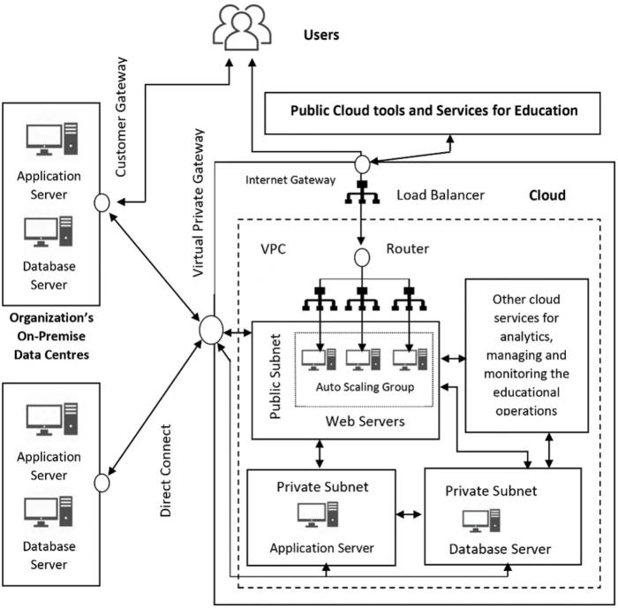

The proposed architecture connects students, faculty and administrators through the Internet to public and private cloud environments. Sensitive university data is maintained in the private cloud, while scalable applications and learning services operate through the public cloud.

Conclusion

The Hybrid Cloud Computing Model is the most suitable solution for the university because it provides flexibility, scalability, cost efficiency and improved accessibility while maintaining the security of sensitive university information. Cloud adoption can overcome the limitations of the existing on-premise infrastructure and support the university's digital transformation.

TASK 2 – Trace the Evolution and Hardware Evolution

Evolution of Computing Infrastructure
Computing technology has changed a lot over the years. Earlier, computers were very large and expensive, but now we can access computing services through the Internet. This development happened through different stages.
Evolution timeline:
- Mainframes (1950s–1960s): These were large computers used by big organizations to store and process huge amounts of data.
- Minicomputers (1970s): They were smaller and cheaper than mainframes, making computers available to more users.
- Personal Computers (1980s–1990s): Computers became available for individual use in homes, colleges and offices.
- Client–Server Computing (1990s): Multiple computers started connecting to a central server to share information and resources.
- Cluster Computing (2000s): Several computers were connected to work together and perform tasks faster.
- Grid Computing (2000s): Computers in different locations shared their resources to complete large tasks.
- Utility Computing (2000s–2010s): Users could access computing resources and pay according to their usage.
- Cloud Computing (2010s–Present): Storage, servers and software became available through the Internet whenever needed.

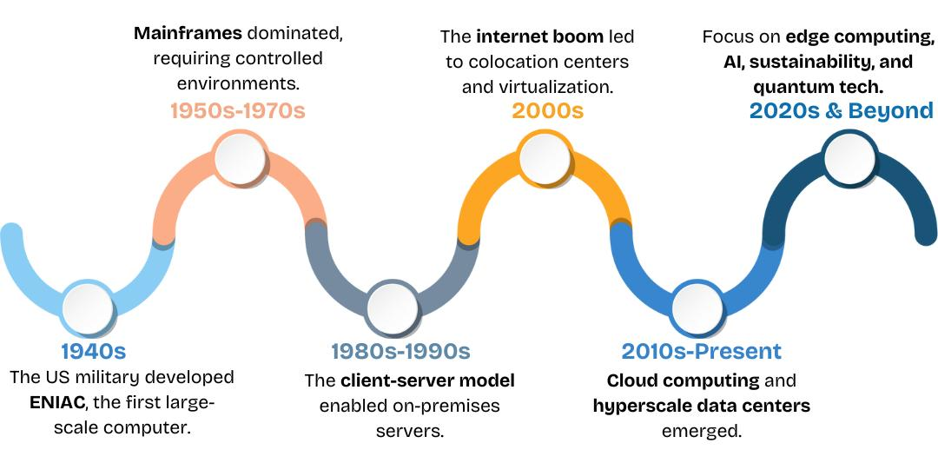

Hardware Evolution

Hardware improvements also played an important role in the development of cloud computing.
- Multi-core Processors: These processors can perform multiple tasks at the same time, improving speed and performance.
- Commodity Servers: These are standard, affordable servers that help organizations reduce hardware costs.
- High-Capacity Storage: Modern storage devices can store large amounts of data, including student records, documents and backups.
- High-Speed Networking: Faster Internet and network connections help users access information without much delay.
- Data Centres: These are large facilities containing servers, storage devices and networking equipment used to provide cloud services.

How Each Stage Solved the Previous Limitations

The development of each stage helped overcome the problems of earlier systems.
- Mainframes to minicomputers reduced the size and cost of computers.
- Minicomputers to personal computers made computing available to individuals.
- Personal computers to client–server systems made sharing information easier.
- Client–server to cluster computing improved processing speed.
- Cluster to grid computing allowed resources from different locations to work together.
- Grid to utility computing introduced payment based on usage.
- Utility computing to cloud computing made services available on demand through the Internet.

University's Current Computing Stage

Our university's current system mainly comes under the Client–Server Computing Stage.
The university uses centralized servers to maintain student details, attendance, examination results and academic information. Students and faculty access these details through the university's systems.
However, maintaining physical servers requires regular maintenance and additional costs. Sometimes, the existing server capacity may not be enough during admissions and examination periods.
So, moving towards a Hybrid Cloud Model would help the university store data securely, increase storage whenever required and provide easy access to students and faculty.

Conclusion

The journey from mainframe computers to cloud computing has made technology faster, more affordable and easier to access. Improvements in processors, storage, networking and data centres have made cloud computing possible. By adopting cloud technology, our university can reduce hardware-related problems and provide better digital services to students and faculty.

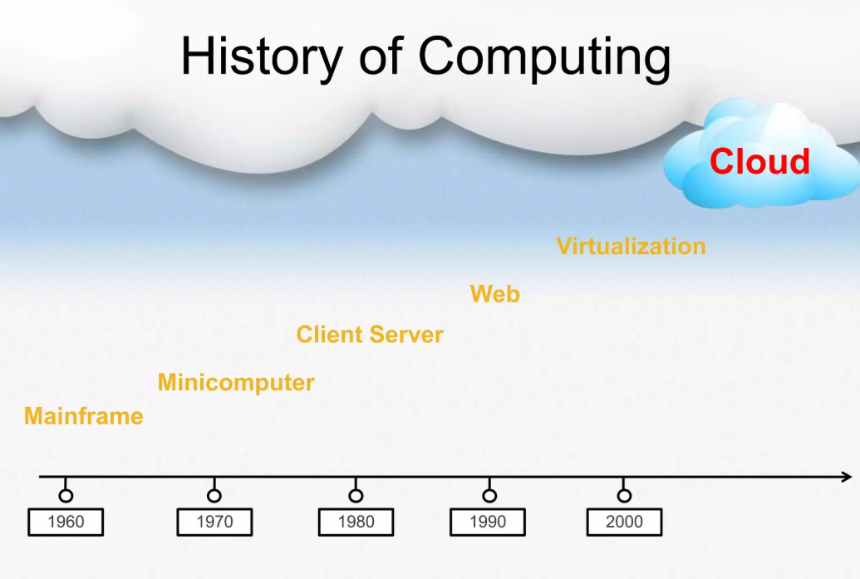

TASK 3 – Analyse Internet Software Evolution

Evolution of Internet Software
Internet software has developed from simple websites into advanced applications that can be accessed from anywhere. This development has made online services faster, easier and more useful.
The evolution happened through the following stages:
- Static Web Pages (1990s): Early websites contained only basic text and images. Users could only view the information.
- Dynamic Web (2000s): Websites became interactive and started displaying information from databases. Users could log in and submit information.
- Web 2.0: Websites allowed users to share photos, videos, comments and other content through social media and online platforms.
- Service-Oriented Architecture (SOA): Software was divided into smaller services that could communicate and work together.
- Mashups: Different online services and data were combined to create a single application.
- Cloud-Hosted Applications: Applications are hosted on cloud servers and can be accessed through the Internet without installing heavy software.

Role of Important Internet Technologies

- Browsers: Help users access websites and web applications using Chrome, Firefox and other browsers.
- HTTP: Transfers information between the browser and web server.
- AJAX: Allows websites to update parts of a page without reloading the entire page.
- APIs: Allow different applications and services to communicate and share information.
These technologies make it possible to access cloud applications easily through the Internet.

Comparison of Different Software Types

Software Type | Description | Example
Desktop Software | Installed and used directly on a computer. | MS Word
Client–Server Software | Runs using a central server and is accessed through a network. | University student portal
Web-Delivered Software | Accessed through a web browser without installing the complete application. | Google Docs

How Internet Software Evolution Supports Cloud Services
The development of Internet software has made cloud computing more useful. Users can now access applications through browsers without depending on a particular computer.
For example, students can attend online classes, download study materials and check examination results from their mobile phones or laptops. APIs also help connect different university applications.

Impact on University Applications
This evolution can improve the university's applications in several ways:
- Online admission and registration systems.
- Cloud-based learning management systems (LMS).
- Online attendance and examination results.
- Easy communication between students and faculty.
- Access to academic information from anywhere.
- Integration of different university services using APIs.

Conclusion
The evolution of Internet software has changed the way people access and use applications. From simple static websites to cloud-hosted applications, each stage has improved accessibility and interaction. By using modern web technologies and cloud services, the university can provide better online facilities to students and faculty.

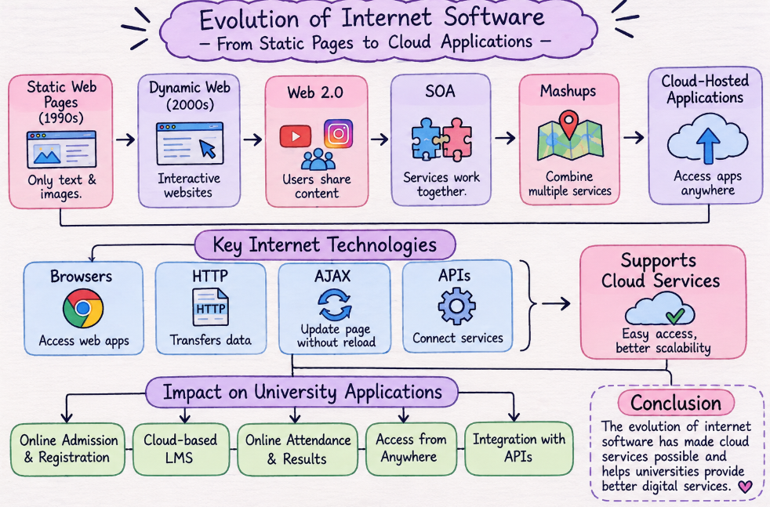

TASK 4 – Apply Server Virtualization

Introduction to Server Virtualization
Server virtualization is a technology that allows multiple virtual servers to run on a single physical server. It helps an organization use hardware resources efficiently and reduces the need to purchase many physical servers.
In our university, there are currently 12 physical servers, but their average utilization is only 15%. This means most of the server capacity is not being used properly. By implementing server virtualization, the university can combine multiple workloads and reduce hardware costs.

Working of a Hypervisor
A hypervisor is software that creates and manages multiple Virtual Machines (VMs) on a single physical server. Each virtual machine works like an independent computer with its own operating system, memory and applications.
There are two types of hypervisors:
Type-1 Hypervisor (Bare Metal):
- Runs directly on the physical hardware.
- Provides better performance and security.
- Mostly used in data centres and organizations.
- Examples: VMware ESXi and Microsoft Hyper-V.
Type-2 Hypervisor (Hosted):
- Runs on top of an existing operating system.
- Mainly used for testing, learning and development.
- Examples: Oracle VirtualBox and VMware Workstation.
For our university, a Type-1 hypervisor is recommended because it is suitable for managing multiple virtual servers.

Types of Virtualization
- Full Virtualization: Creates a complete virtual environment where an operating system runs without modification. It provides good compatibility with different operating systems.
- Para-Virtualization: The guest operating system is modified to communicate with the hypervisor, which can improve performance.
- OS-Level Virtualization (Containers): Multiple isolated containers share the same operating system kernel. They are lightweight and start quickly. Docker is an example.
- Hardware-Assisted Virtualization: Uses processor technologies such as Intel VT-x and AMD-V to improve virtualization performance.

Applications Suitable for VMs and Containers
The university can divide its applications based on their requirements.
Virtual Machines (VMs):
- Database servers – require separate operating systems and better isolation.
- Examination management system – handles important examination data.
- Finance and administration systems – contain sensitive information.
- Legacy applications – may require specific operating systems.
Containers:
- Student portal frontend – can be deployed quickly.
- Web applications – easy to update and manage.
- APIs and microservices – can run independently.
- Development and testing applications – support faster development.
Using VMs for important applications and containers for lightweight applications will help the university manage its resources efficiently.

Benefits of Server Virtualization
- Live Migration: Virtual machines can be moved from one physical server to another with very little downtime.
- Snapshots: Save the current state of a virtual machine and allow recovery if something goes wrong.
- Resource Over-commitment: Allows virtual machines to be assigned more virtual resources than the physical server has, based on expected usage. It must be monitored carefully.

Risks of Virtualization
- Noisy Neighbour: One virtual machine may use too many resources and affect the performance of other VMs.
- Hypervisor Failure: If the hypervisor fails, multiple virtual machines running on it may become unavailable.
- Security Isolation: Weak security configurations may allow attacks to affect other virtual machines or the host system.

Conclusion
Server virtualization will help our university reduce the number of physical servers from 12 to 3 minimum hosts. It improves resource utilization, reduces hardware and maintenance costs and makes server management easier. By using suitable virtual machines and containers, the university can provide better performance and reliable services.

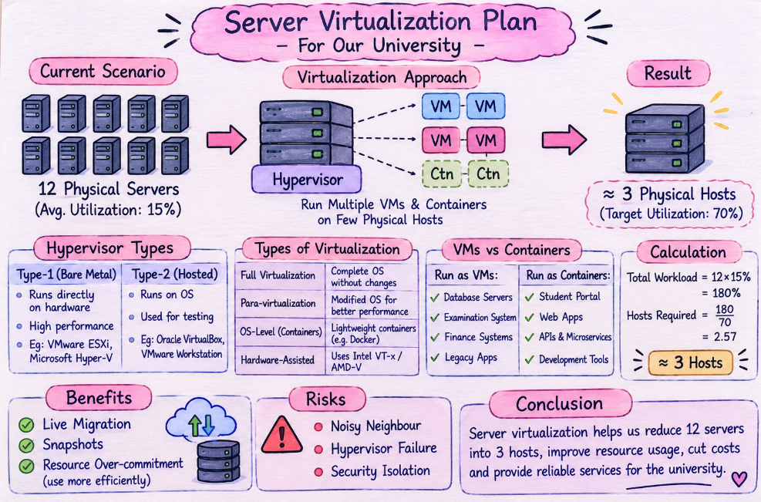

TASK 5 – Apply Web Services

Introduction to Web Services
Web services allow different applications to communicate and exchange information through the Internet. They help connect university systems such as student portals, examination systems, fee payment and library management.

Types of Web Services
- SOAP: Uses XML to exchange data and provides structured communication.
- WSDL: Describes the operations and formats of a web service.
- UDDI: Helps register and discover available web services.
- REST: Uses HTTP methods like GET, POST, PUT and DELETE. It commonly uses JSON or XML.

Comparison

Technology | Purpose
SOAP | XML-based communication
WSDL | Describes web services
UDDI | Finds web services
REST | Simple communication using HTTP and JSON/XML

Justification

REST is suitable for result lookup and library search because it is simple and fast. For fee payment, REST can integrate with modern payment gateways, while SOAP may be used if the payment provider requires it.

Benefits
- Easy communication between applications.
- Reduces manual work.
- Provides quick access to student services.
- Supports mobile and web applications.
- Improves data sharing.

Conclusion
Web services help the university connect different applications and provide online facilities. REST is a suitable choice for most university services because it is flexible, simple and easy to maintain.

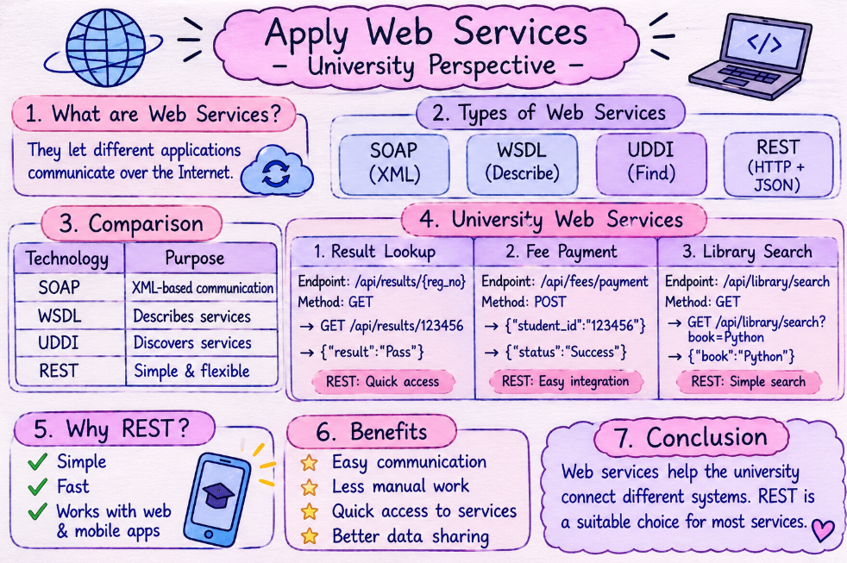

TASK 6 – Analyse the Service Models: IaaS, PaaS and SaaS

Introduction
Cloud computing provides three main service models: IaaS, PaaS and SaaS. Each model offers different levels of control and responsibility. These services help universities manage applications, store data and provide online facilities without depending completely on physical servers.

Definition of IaaS, PaaS and SaaS
- IaaS (Infrastructure as a Service)
IaaS provides virtual servers, storage and networking through the Internet. The cloud provider manages the physical hardware, while the university manages the operating system and applications.
Example: Amazon Web Services (AWS EC2).
- PaaS (Platform as a Service)
PaaS provides a ready-made platform to develop, test and run applications. The provider manages the infrastructure and software platform, allowing developers to focus on building applications.
Example: Google App Engine.
- SaaS (Software as a Service)
SaaS provides ready-to-use software through the Internet. Users can access applications using a browser without installing or maintaining the software.
Example: Microsoft 365.

Responsibility of Each Service Model

Layer | IaaS | PaaS | SaaS
Hardware | Provider | Provider | Provider
Storage & Network | Provider | Provider | Provider
Operating System | User | Provider | Provider
Runtime | User | Provider | Provider
Applications | User | User | Provider

Categorisation of University Applications

Application | Model | Reason
SIS | Iaas | More control over student data
LMS | Saas | Ready-to-use learning platform.
Library | Saas | Easy online book access
Exam Portal | Paas | Supports custom development
Email | Saas | Ready-to-use email service

Real-World Provider Examples
- IaaS: Amazon Web Services (AWS) – Provides virtual servers and storage.
- PaaS: Google App Engine – Provides a platform to develop and deploy applications.
- SaaS: Microsoft 365 – Provides online email, documents and collaboration tools.

Conclusion
IaaS, PaaS and SaaS provide different ways to use cloud services. IaaS gives more control, PaaS makes application development easier and SaaS provides ready-to-use software. By selecting the correct model for each application, the university can reduce maintenance work, improve accessibility and manage its IT resources efficiently.

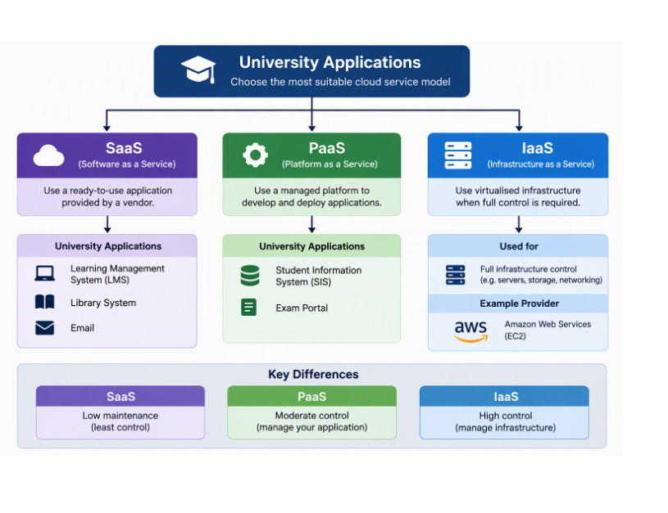

TASK 7 – Examine XaaS

Introduction to XaaS
XaaS stands for Anything-as-a-Service. It means different IT services are provided through the Internet instead of installing and maintaining everything on physical computers. It helps universities reduce costs and access services whenever required.

Types of XaaS
- DaaS (Desktop-as-a-Service): Provides virtual desktops that students and faculty can access from anywhere.
- DBaaS (Database-as-a-Service): Provides online database storage and management without maintaining physical database servers.
- FaaS (Function-as-a-Service): Allows developers to run small code functions without managing servers.
- BaaS (Backend-as-a-Service): Provides ready-made backend services for applications, such as authentication and data storage.
- Security-as-a-Service: Provides online security tools to protect university data and applications.
- DRaaS (Disaster Recovery-as-a-Service): Helps recover data and applications after system failures or disasters.

Two XaaS Services Suitable for the University
- DBaaS (Database-as-a-Service)
The university can use DBaaS to store student details, attendance, examination results and staff information. It reduces database maintenance work and provides easy data access.
- DRaaS (Disaster Recovery-as-a-Service)
The university can use DRaaS to back up important academic records and restore them during server failures or unexpected disasters. It helps prevent data loss and maintain university services.

Risks of Depending on Multiple XaaS Providers
- Security Issues: Student and university data may be exposed if providers have security weaknesses.
- Vendor Lock-in: Moving data from one provider to another may be difficult.
- Internet Dependency: Services may become unavailable when the Internet connection fails.
- Additional Costs: Using multiple subscriptions can increase expenses.
- Integration Problems: Different providers may not work properly together.

Conclusion
XaaS helps universities access different IT services without maintaining all the infrastructure themselves. DBaaS and DRaaS are useful for managing university data and protecting important records. However, the university should select reliable providers and maintain proper security and backup plans.

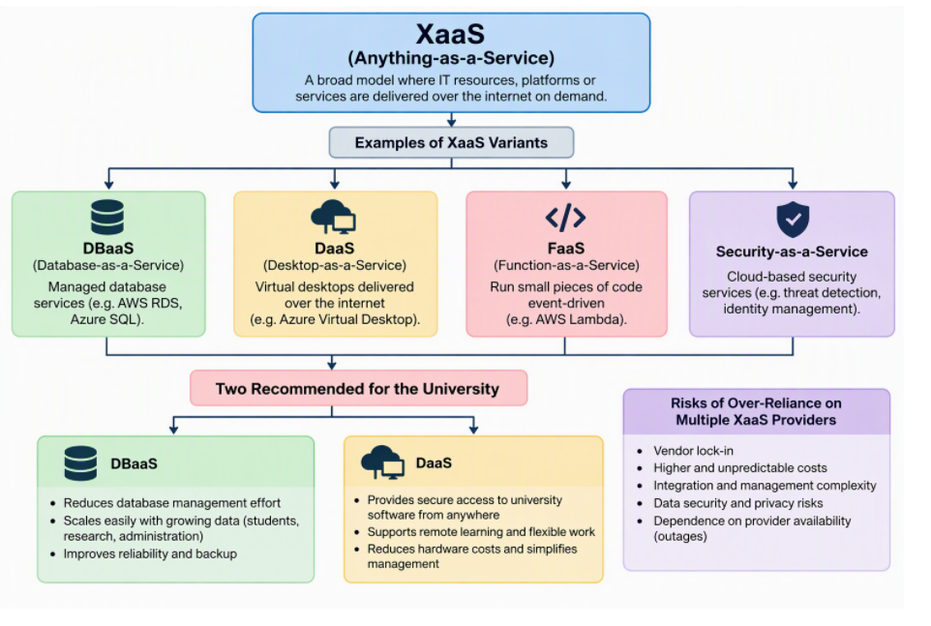
TASK 8 – Design the Cloud Solution Architecture

Proposed Cloud Architecture
The university can use a Hybrid Cloud Architecture to manage student records, admissions, examinations, fees, library services and online learning. It combines virtualization, web services and cloud service models to provide a secure, scalable and reliable system.

Architecture Diagram
The architecture follows this flow:
Users → Load Balancer → Web/Application Tier → API Layer → Database and Storage
A separate Disaster Recovery (DR) region is maintained to protect important university data.

Components and Service Models

Component | Service Model | Purpose
Users | Public Cloud | Access services
Load Balancer | IaaS | Distributes traffic
Web/Application Tier | PaaS | Runs university applications
API Layer | PaaS | Connects services
Database & Storage | DBaaS / Storage-as-a-Service | Stores university data

Elasticity and Auto-Scaling
The cloud system uses auto-scaling to handle changes in user traffic.
- During admissions: More students access the admission portal, so additional web and application servers are automatically created.
- During examinations: Extra resources are added to support online exams and result processing.
- During normal days: Unused servers are reduced to save cost.
- The load balancer distributes traffic equally among available servers to avoid overloading.
Security and Availability Measures
- Access Control: Role-based access is provided for students, faculty and administrators.
- Encryption: Data is encrypted during transmission and storage.
- Backup: Regular backups are maintained for student records and examination data.
- Multi-Zone Deployment: Applications run across multiple availability zones to avoid service interruption.
- Disaster Recovery: A separate DR region is used to restore services if the main region fails.
- Monitoring: Continuous monitoring helps detect failures and unusual activities.

Justification of the Design
- Hybrid cloud provides both flexibility and better control over sensitive university data.
- Virtualization allows multiple virtual servers to run on fewer physical machines, reducing hardware costs.
- Web services and REST APIs allow different university applications to communicate easily.
- PaaS simplifies application development and maintenance.
- IaaS provides control over virtual machines, databases and storage.
- Auto-scaling handles heavy traffic during admissions and examinations.
- Backup and disaster recovery help protect important academic information.

Conclusion
The proposed hybrid cloud architecture provides a scalable, secure and cost-effective solution for the university. By combining virtualization, web services, IaaS, PaaS and SaaS-based services, the university can improve performance, reduce maintenance and provide uninterrupted digital services to students and staff.
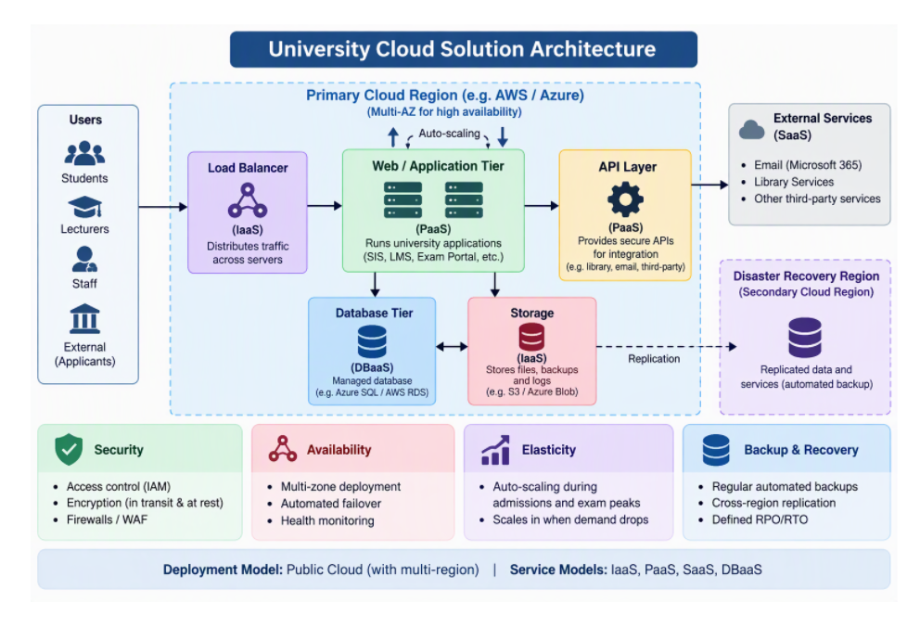
TASK 9 – Hands-on Implementation and Documentation

Aim
To create a simple cloud-based university application using a virtual container and test its web service.

Tools Used
- Docker: To create and run a virtual container.
- Python Flask: To develop a REST API.
- GitHub Pages: To host a simple static webpage.
- Browser: To test the application.

Implementation Steps
- Install Docker and Python on the system.
- Create a simple Flask application for checking student results.
- Build a Docker image and run the application inside a container.
- Create a static university webpage and deploy it using GitHub Pages.
- Open the API address in a browser to test the service.

Screenshots to Attach
- Docker container running.
- Flask application running in the terminal.
- University webpage opened in the browser.
- REST API output displayed in the browser.

Issues Faced
- Initial difficulty installing and configuring Docker.
- Errors while running the Flask application.
- Resolved the issues by checking the configuration and correcting the commands.
Conclusion
The proof-of-concept demonstrates how a university application can run inside a container and provide student information through a REST API. It shows how cloud technologies simplify application hosting and access.

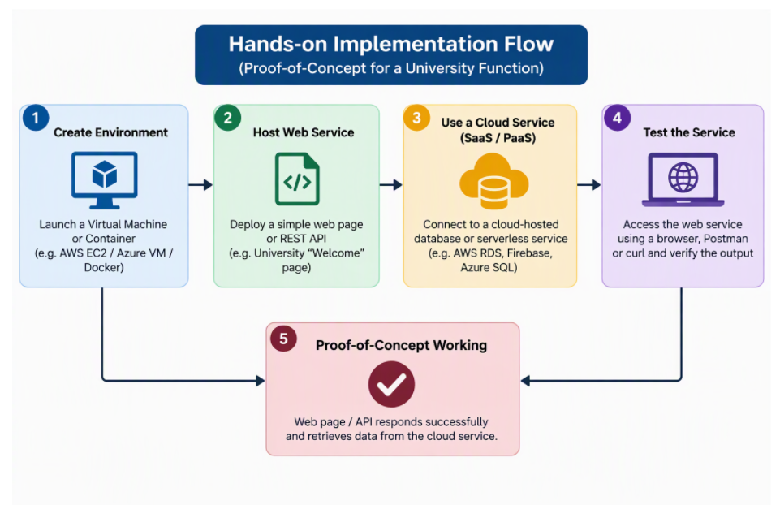

TASK 10 – Evaluate and Recommend the Final Solution

Comparison of Cloud Solutions

Factor | On-Premise | IaaS | PaaS/SaaS
Cost | High CapEx | Pay-as-you-use | Subscription
Scalability | Low | high | Very high
Availability | Limited | high | High
Security | Local control | Shared | Provider-managed
Effort | high | medium | low

Three-Year Cost Comparison
Estimated cost for a university with 12 servers
Cost | On-Premise | Iaas | Paas/Saas
Setup | ₹30 lakh | ₹3 lakh | ₹4 lakh
3-year running cost | ₹12.6 lakh | ₹45 lakh | ₹33 lakh
total | ₹42.6 lakh | ₹48 lakh | ₹37 lakh

Final Recommendation
I recommend a Hybrid Cloud Model using IaaS, PaaS and SaaS. It provides better scalability, security, availability and cost management while protecting sensitive university data.

Migration Roadmap
- Move the university website and email first.
- Migrate LMS and library applications.
- Move admission, attendance and fee systems.
- Migrate databases and examination systems.
- Enable backup and disaster recovery.

Conclusion
Hybrid cloud is suitable for the university because it reduces maintenance, handles peak traffic and provides secure and reliable services.
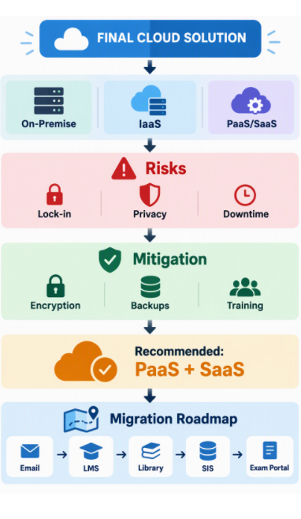
TASK 11 – Re-evaluate and Adapt the Design

Design Decision
I would MODIFY the original hybrid cloud architecture to support the mobile app and 40 affiliated colleges.

Changes Required
- Add a mobile application connected through secure REST APIs.
- Use auto-scaling to handle 10 times the current peak traffic.
- Provide separate login access for each affiliated college.
- Use a centralized database for student records and fee payments.
- Deploy services across multiple availability zones to achieve 99.9% availability.

Updated Architecture
- Mobile App and Web Portal
- Load Balancer and API Gateway
- Auto-scaling Application Servers
- Secure Database
- Cloud Storage and Backup
- Separate Disaster Recovery Region

Security Improvements
- Role-based access for students, colleges and administrators.
- Encrypt student and payment information.
- Use secure payment gateways.
- Enable multi-factor authentication for administrators.
- Maintain regular backups and activity logs.

Cost Management
- Use PaaS and SaaS to reduce maintenance costs.
- Apply auto-scaling to avoid unnecessary server expenses.
- Use storage based on actual requirements.
- Monitor cloud usage and set budget alerts.

Availability and Performance
- Deploy applications across multiple zones.
- Use load balancing to distribute traffic.
- Maintain backup services in a separate region.
- Monitor performance to maintain 99.9% availability.

Benefits of the Modified Design
- Supports 40 affiliated colleges.
- Handles 10 times the current peak load.
- Provides secure mobile and web access.
- Reduces infrastructure and maintenance costs.
- Improves availability and performance.

Conclusion
The modified hybrid cloud architecture is suitable for the university's new requirements. It supports more users, provides secure mobile services, maintains 99.9% availability and controls costs through auto-scaling and managed cloud services.
